In this IOT project ,some sensors and actuators are connected to raspberry PI. Sensors are soil moisture sensor and temperature sensor connected to Raspberry Pi3 model B via MCP3208 12-bit Analog-to-Digital Converter (ADC). Sensors collect data from the required field and send it to Raspberry pi. Pi then sends data to the cloud for necessary data processing. Cloud replies back with necessary steps.
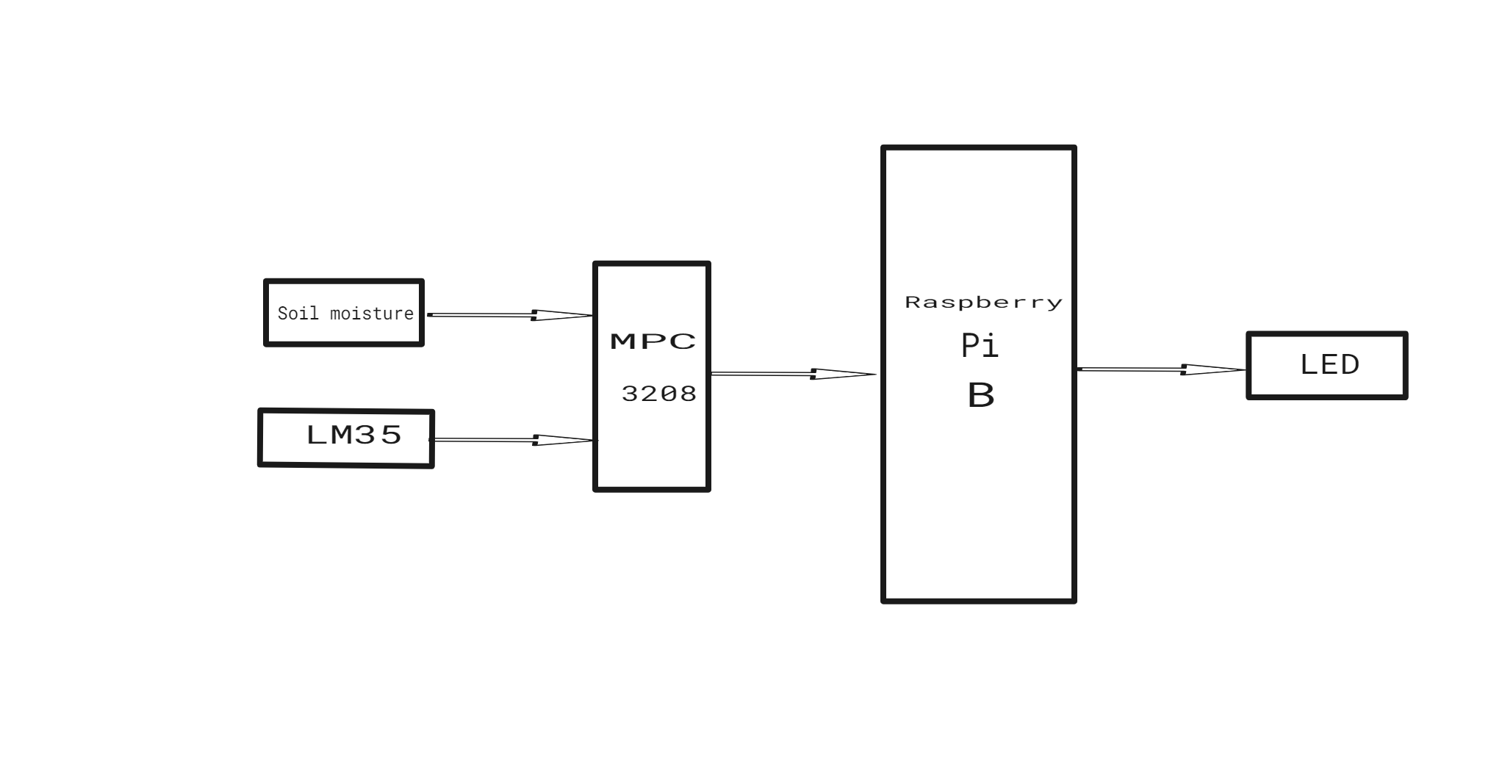

I2C Communication:
- The ADS1115 analog-to-digital converter (ADC) communicates with the Raspberry Pi using the I2C protocol. I2C (Inter-Integrated Circuit) is a synchronous, multi-master, multi-slave, packet-switched, single-ended, serial communication bus. It uses two lines:
  - SDA (Serial Data Line)
  - SCL (Serial Clock Line)
This protocol allows the Raspberry Pi to communicate with multiple I2C devices using the same two wires.
# Create the I2C bus
i2c = busio.I2C(board.SCL, board.SDA)
Single-Ended Analog Input:
- The soil moisture sensor is connected to the ADS1115 ADC. The ADC reads the analog signal from the sensor and converts it to a digital value. The communication between the soil moisture sensor and the ADS1115 is an analog signal, not a digital communication protocol.
- The code sets up a single-ended input on channel 0 of the ADS1115:
# Create single-ended input on channel 0
chan = AnalogIn(ads, ADS.P0)

From EDge to cloud they are connected via mqtt.
MQTT (Message Queuing Telemetry Transport) is a lightweight, publish-subscribe network protocol that transports messages between devices. It is designed for constrained devices and low-bandwidth, high-latency, or unreliable networks, making it ideal for Internet of Things (IoT) applications.

Key Features of MQTT:
- Publish-Subscribe Model:
  - Publisher: Sends messages to a topic.
  - Subscriber: Receives messages from a topic.
  - Broker: Manages topics and routes messages from publishers to subscribers.
2. Quality of Service (QoS) Levels:
- QoS 0: At most once delivery (fire and forget).
- QoS 1: At least once delivery (message acknowledgment).
- QoS 2: Exactly once delivery (message assurance).

How MQTT Works:
- Connection:
  - Clients establish a connection with the broker.
- Publishing:
  - Publishers send messages to the broker on a specified topic.
- Subscription:
  - Subscribers subscribe to topics they are interested in.
- Message Delivery:
  - The broker routes messages from publishers to subscribers based on the topics.

Github Link:
https://github.com/tejpata51/tejpata51.git

